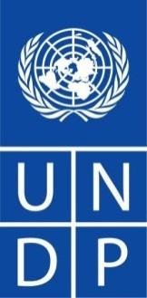

**Support to the Lebanese Palestinian Dialogue Committee/Phase 3**

**Project ID 00084573**

**Annual Progress Report**

**Reporting period:**

**January – December 2013**

TABLE OF CONTENT

I- INRODUCTION 5

II- PROJECT BACKGROUND and OBJECTIVES 7

1) Context Analysis 8

2) Outputs 2012 – 2013 9

3) Executive Agency 10

III- PROGRESS 11

1) Output 1: LPDC inter-ministerial committee strengthened to implement its mandate; and the “Technical” and “Camp Management & Security” committees established and running 11

2) Output 2: LPDC acts as the focal point for national and international partners on issues regarding Palestinian refugees in camps and surrounding communities, including the reconstruction of Nahr el Bared camp: 13

3) Output 3: Policy and substantive advice provided to the inter-ministerial committee and the Government of Lebanon on Palestinian Refugees civil rights 20

IV- MAJOR ACHIEVEMENTS 2013 23

1) Towards a Unified National Policy for the Palestinian Refugees in Lebanon and a future vision for LPDC 23

2) UNRWA Advisory Commission (AdCom) meeting/ June 17, 2013 (Dead Sea, Jordan) 26

V- COMMUNICATION AND OUTREACH 27

1) Tools: Website, Social media and Newsletters 27

VI- IMPACT 28

VII- KEY CHALLENGES 29

1) Inter– governmental level: 29

2) External – field: camps and gatherings level: 29

3) Project implementation Level: 29

VIII- PROPOSED ACTION PLAN 30

1) Establishment of the National Observatory for Palestinian Affairs 30

2) Enhancing Lebanon’s Response to the influx of Palestinian refugees from Syria: Monitoring Service Delivery in the Palestinian Camps of Lebanon 32

ANNEX 1 33

ANNEX 2 36

# INRODUCTION

Based on the UNRWA records of 1948, the total number of registered Palestinian refugees is 425,000 residing in 12 camps and other gatherings, representing 10% of the Lebanese population. According to the 2010 American University of Beirut (AUB) *“Socio-Economic Survey of Palestine Refugees in Lebanon*”[1], of the 425,000 registered refugees only 260.000-280.000 currently reside in Lebanon, half of the population is younger than 25 year-old. 56% of refugees are jobless and only 37% of the working age population is employed: of the 120.000 Palestinian members of the Labor force, only 53.000 are working; 6% of this labor force has university training compared to 20% of the Lebanese labor force. For the higher education, only 13% of refugees older than 18 have the Baccalaureate or higher, compared to 17% for the Lebanese population.

They are frequently reported to face the worse living conditions among Palestinian refugees in the host countries of the Middle East. According to UNRWA, all 12 official refugee camps in Lebanon suffer from improper infrastructure, overcrowding, poverty and unemployment. UNRWA reports that Lebanon has the highest percentage of Palestinian refugees who are living in poverty and who are registered with the Agency’s “special hardship” programme. The AUB survey maintains that 2/3 of the Palestinian refugees are considered to be poor (160.000 individuals) with 6.6% under the line of extreme poverty.

The Palestinian camps consistently register social and economic indicators below national and regional averages. Palestinian refugees, many of which have resided in the country for more than 60 years, are regarded as foreigners and excluded from basic civil and socio-economic rights, including the right to work. Palestinian refugees work mainly in construction and manual labor. Others are left to work in the informal sector and are subjected to discrimination and exploitation. Only in 2005 did the Government of Lebanon issue a decree authorizing access of Palestinian refugees to eighty professional categories of jobs previously withheld from them. Additionally, they have restricted access to public education, adequate housing, and health services and are practically banned from forming associations. The Lebanese parliament issued law number 129 on August 17, 2010 amending article 59 of the 1946 labor law which stipulates the need for work permit tariffs and the reciprocity condition. The 2010 amendments revoked such tariffs and reciprocity conditions, a step anticipated to have a very positive impact on Palestinian refugees’ access to the labor market. Unfortunately, the needed implementation decrees to enforce this law are yet to be issued by the Minister of Labor.

In recent years, at the strategic level, the official Lebanese policy towards Palestinian refugees has undergone change to improve the living conditions of Palestinian refugees, while continuing to stress the right of return of the Palestinian refugees. The government of Prime Minister Fouad Siniora was the first to take a new approach toward Palestinian refugees, starting with the appointment of a dedicated inter-ministerial committee in 2005. The Lebanese Working Group on Palestinian Refugees, which became later known as the Lebanese-Palestinian Dialogue Committee (LPDC), was created in November 2005 by the Council of Ministers, in response to the goal set by the Government of Lebanon (GoL) to improve the living conditions of Palestinian refugees in Lebanon. As per the official decree (41/2005), the LPDC committee’s broad mandate includes:

* Improving the living conditions of Palestinians residing in and outside refugee camps in Lebanon, in collaboration with UNRWA;
* Initiating a dialogue to manage the issue of arms inside the camps;
* Putting an end to the possession of illegal arms outside the camps;
* Studying opportunities for establishing diplomatic relations and representation between Lebanon and Palestine.

During the consecutive cabinets headed by Prime Minister Fouad Siniora, Ambassador Khalil Mikkawi was appointed as the president of the LPDC. This improved official Lebanese policy towards Palestinian refugees continued and was adopted by both Prime Minister Saad Hariri and currently with Prime Minister Najib Mikati. However, it is important to note out that the changes in the Lebanese political landscape had an impact on where the Palestine refugee file fits in within the list of priorities. Moreover, the presidency of the LPDC has witnessed three changes from 2009 to date. Me. Maya Majzoub served during PM. Saad Hariri’s unity cabinet (2010-2011) after Ambassador Mikkawi’s resignation at the end of 2009. She was later replaced by Ambassador Abdelmajid Kassir who was assigned by PM. Mikati in August 2011; he served until June 2012, when Dr. Khaldoun el Charif was appointed to head LPDC.

This rotating leadership had an impact on LPDC’s overall direction, flow of work, and positioning on the level of the support provided by UNDP due to the various transition and adaptation periods.

|  |  |  |  |
| --- | --- | --- | --- |
| **Period** | **Prime Minister** | **Government** | **LPDC Presidency** |
| July 2005–July 2008 | Fouad Siniora | Reform and Recovery | Amb. Khalil Mikkawi |
| July 2008–June 2009 | Fouad Siniora | The Unity National Will | Amb. Khalil Mikkawi |
| Nov 2009–June 2011 | Saad Hariri | Development and Progress | Me. Maya Majzoub |
| June 2011–June 2012 | Najib Mikati | All for Work | Amb. Abdelmajid Kassir |
| July 2012 - present | Najib Mikati | All for Work | Dr. Khaldoun el Charif |

# 

# PROJECT BACKGROUND and OBJECTIVES

Based on initial consultations with IDRC/Canada, and upon subsequent request from the Lebanese Government, the United Nations Development Programme (UNDP) initiated its support to the LPDC in October 2006 and helped establish the technical team which currently serves as the secretariat for the Committee. A project document which further outlines the joint areas of collaboration was signed by the government and UNDP in January 2007. This project was initially extended for an additional three years 2009-2011, based on a substantive revision of this initiative in January 2009. Canada/IDRC has been the main funder to the LPDC since January 2007, and has supported the second phase of the project which was initiated at the beginning of 2009. UNDP also mobilized additional support for the LPDC’s project from Italy, and the UN Joint Programme on “Conflict Prevention and Peace Building in the North” funded by the MDG Fund, and the Swiss Agency for Development and Cooperation (SDC).

This project builds upon the United Nations Development Assistance Framework 2010-2014 (Outcome 1: by 2014, governance reforms and practices, with focus on national dialogue and inclusive participation, and government effectiveness and accountability, are institutionalized at all levels). It is also in line with UNDP’s Country Programme Document (CDP) and Country Programme Action Plan (CPAP), which identifies “improving living conditions and trust among Palestinian and Lebanese surrounding communities” as a key priority area.

During the course of the four presidencies of the LPDC, the objective of the project remained to strengthen the capacity of the LPDC to develop and implement a comprehensive policy on the Palestinian refugee issues, with a view to improving the living conditions of Palestinian refugees in Lebanon. Nonetheless, the transition period from Ambassador Mekkawi to Me. Majzoub witnessed a re-alignment of project outputs with the vision of the new LPDC president and Government in June 2010. As for the current period headed by Ambassador Kassir, then Dr. Khaldoun el Charif, the outputs remain the same, as stipulated in the project document.

The project outcomes remained as follows:

1. Improved policy and planning capacity of LPDC, in relation to Palestinian refugees issues in Lebanon;
2. Enhanced public awareness and knowledge of Lebanese institutions and other national and international stakeholders of the situation of Palestinian refugees in Lebanon.
3. Fostered basic and fundamental rights of Palestinian refugees.

## Context Analysis

With the formation of the current cabinet headed by PM. Mikati and the appointment of Ambassador Kassir as a president to LPDC, the government renewed it commitment towards the Palestinian refugees in Lebanon through the Ministerial Statement and its adoption to the existing work plan of the LPDC. Shortly after, Dr. Khaldoun el Charif took the helm of LPDC with a renewed support of Prime Minister Mikati and full back up of all LPDC activities.

The cabinet’s commitment was clearly voiced in articles 12 and 13 of the Ministerial Statement as outlined below.

*“12 – The cabinet renews its call to implement International resolutions that preserve the right of the Palestinian people to self-determination, return to his homeland and establishment of a free independent state with Jerusalem as its capital. It also stresses its support to the right to return and rejection of settlement in all its forms. The cabinet also renews Lebanon’s attachment to the Arab Initiative for Peace that was adopted by the Beirut Summit in 2002 in such a way as to safeguard Arab rights and the rights of the Palestinian people. Until the complete return (of the Palestinian refugees), the government will work on ensuring the human and social rights of Palestinians living on Lebanese soil, implementing the laws that were adopted by your esteemed Council (It is addressed to Parliament) and looking after the Palestinian camps particularly Nahr el-Bared camp with a view to completing its reconstruction after securing the necessary funds for that from Arab and International contributions. The government will call for strengthening UNRWA’s budget in order to allow the Agency to fulfill its humanitarian mission at the service of Palestinian refugees as before.*

*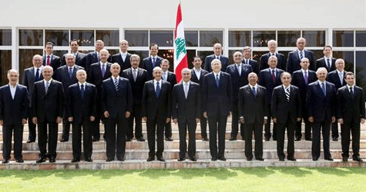13 – The cabinet highlights the importance of maintaining national dialogue as a need to solve political conflicts and nurture the culture of dialogue amongst the Lebanese. It is also concerned with implementing the decisions of the national dialogue relating to ending the presence of Palestinian arms outside the Palestinian refugee camps and addressing the issues of security and weapons inside the camps. The cabinet also stresses that protecting the camps and maintaining the Palestinians’ security residing there, is the State’s responsibility only. ”*

## Outputs 2012 – 2013

To achieve these objectives, the project “support to the Lebanese Palestinian Dialogue Committee- Phase 3” staged the following outputs:

• Output 1: LPDC inter-ministerial committee strengthened to implement its mandate; and the “Technical” and “Camp Management & Security” committees established and running;

• Output 2: LPDC acts as the focal point for national and international partners, on issues regarding Palestinian refugees in camps and surrounding communities, including the reconstruction of Nahr el Bared camp;

• Output 3: Policy and substantive advice provided to the inter-ministerial committee and the Government of Lebanon on Palestinian Refugees civil rights.

In this sense, key elements of the support to the LPDC President and the Government of Lebanon (GoL) included:

* Strengthening the provision of technical and policy advice to the Government of Lebanon and the LPDC, as a secretariat, with a clearer focus on legal reforms concerning the civil rights of Palestinian refugees;
* Strengthening the function of focal point of the LPDC within the Government of Lebanon for the Palestinian file, in order to work as an intermediary with Ministries to facilitate processes and resolve conflicts, as well as to act as a fire-fighter on issues being communicated by a wide range of stakeholders;
* Ensuring technical follow-up on matters related to the reconstruction of Nahr El Bared, in coordination with governmental counterparts, and with UNRWA;
* Building a knowledge base on the situation of Palestinian refugees in Lebanon, to devise evidence-based approaches to policy making, and to effectively support policy changes;
* Strengthening the communications aspect of the work of the LPDC allowing it to develop and implement a multi-actor and multi-level awareness-raising and outreach strategy;
* Strengthening the presence of the LPDC in relation to the other Palestinian camps in Lebanon, in order to gain a broader understanding of emerging issues and solve problematic situations.

## Executive Agency

The Prime Minister’s Office/ Lebanese Palestinian Dialogue Committee (LPDC)/ is designated as the National Executing Agency for this project. The Executing Agency is responsible for managing the project and provides overall support to achieving its intended outputs and results.

Moreover, all services are provided in accordance with UNDP procedures, rules and regulations. The LPDC is responsible for and bound by any contracts signed by the UNDP, on behalf of the LPDC and upon its request, for the procurement of goods and services and / or recruitment of personnel for the programme.

# PROGRESS

## Output 1: LPDC inter-ministerial committee strengthened to implement its mandate; and the “Technical” and “Camp Management & Security” committees established and running

The meetings of the LPDC inter-ministerial committee have been suspended in 2013 due to the political/security context in the country and due to the modest and rather incomplete ministries representation which compromised the committee ability to influence decision-making. However, the LPDC president compensated this shortfall by meeting regularly with ministers, director generals’ and senior public officials’ in-charge of Palestinian affairs. This allowed the LPDC to outreach on more senior level and upscale its impact.

1. ***Technical Assistance to the Government of Lebanon (GoL)***

In line with its on-going efforts to strengthen the capacity of member ministries and enhance cooperation, the LPDC inter-ministerial committee was reactivated in 2010. The idea was to form a task force between ministries to deal with any upcoming issue. Their role was to provide their input and contribution to solve problems. LPDC had to assume the role of “**coordinator and interlocutor**” linking UNRWA and other Palestinian actors to the relevant Lebanese ministries and administrations. Unfortunately, the representatives of the various ministries were not empowered with the needed authority to provide data or action. Hence, the inter-ministerial Committee’s meetings were held and the LPDC president and technical team assumed the coordination and interlocutor roles.

Moreover, towards the end of 2013 the PM has formed a National team under his chairmanship including the Minister of Interior, Director of General Security, Director of Central Administration of Statistics and the LPDC president. This team have met twice and focused on the measure needed to establish the National Observatory for Palestinian Affairs.

1. ***Capacity-building for the LPDC Team members***

Building capacity for the LPDC team members is a strategic component that enabled LPDC to better respond to the refugee crisis, building on international experiences and lessons learned from others parts of the world with similar conflicts. It aimed to develop specific areas in Peacebuilding and Conflict Prevention to improve LPDC field team respond to conflict situation during their missions. Another area of development focused on the respond to humanitarian crisis like the PRS current crisis.

## Output 2: LPDC acts as the focal point for national and international partners on issues regarding Palestinian refugees in camps and surrounding communities, including the reconstruction of Nahr el Bared camp:

This output was the LPDC’s project main focus in 2013. It tried to breach in four tracks: First, towards the Palestinian Community and representatives by increasing the Field presence for the LPDC support team and resolving pertaining problems. Second, the LPDC president has been widely establishing communication with International and National stakeholders that works on the refugee issue. Third, he also exercised extended efforts to engage the public institutions chiefs and senior decision makers on the Palestinian context in Lebanon. Last, the LPDC established contact and knowledge of parallel institutions in other host countries as well as increasing its International exposure on the regional case of the Palestinian refugees through ADCOM meetings.

1. ***Strengthening Cooperation and collaboration with the Palestinian Partner:***

* **Embassy of Palestine**

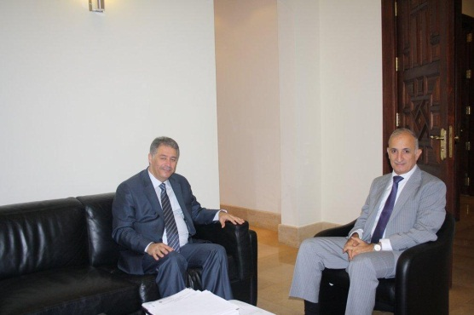Regular meetings and consultations are constantly taking place and at various occasions to update the embassy and coordinate at the official level. The coordination with the embassy had many positive repercussions on the administrative and international level in simplifying the administrative procedures and supporting the stance of Palestine in international forums.

* **Popular Committees and Representatives of Palestinian Refugee communities**

With the aim of strengthening relations with the Palestinian refugee communities in Lebanon, the LPDC under the presidency Dr. Khaldoun el Charif, carried out a number of Coordination Meetings with representatives of the various Palestinian Factions.

|  |  |  |  |
| --- | --- | --- | --- |
| 2013-08-05-Pal Emb and Fat7 |  | 2013-08-05-jabha shaabyeh |  |

LPDC’s President, Khaldoun, also met with various Palestinian factions, to discuss setting mechanisms of coordination. He invited the various representatives to attend the workshops aimed at presenting the draft of an official policy for Lebanon towards the Palestinian presence on Lebanese territory.

There was a common agreement on the challenges that are facing Lebanon at this delicate juncture of regional and international turmoil and the need to join efforts to come up with a new insight for a future collaboration that would secure the stability of Lebanon and a better living environment for the Palestinian refugees inside and outside the camps.

* ***Seeking to deal with the Influx of Palestinian Refugees coming from Syria***

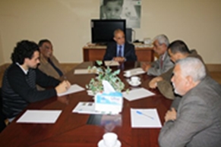LPDC’s president, Dr. Khaldoun el Charif, met with representatives of the Beddawi Popular Committee to discuss issues related to the displaced Palestinian refugees those coming from Syria as well as those coming from Nahr el Bared and residing in Beddawi since 2007. The participants set up a Road Map to follow up on the Camps’ situation and coordinate efforts to deal with the arising problems. The LPDC president also coordinated the efforts between the Director General of Security General and UNRWA to ensure the resolve border access issues and recommended the automatic renewal of PRS temporary residency. He remained a strong supporter and advocated strongly to maintain the border accessible for PRS as well as to Syrian refugees.

1. ***LPDC’s role as the Focal Point for National Partners:***

* **UNRWA Director Discusses the Situation of Palestinian Refugees coming from Syria**

February, 2013—UNRWA Lebanon Director, Ann Dismorr, and LPDC technical team held a coordination meeting at the Grand Serail with the various local and international NGOs working towards improving the living conditions in Palestinian gatherings in terms of improving services, infrastructure, shelter and residential units’ rehabilitation.

The participants reviewed the ongoing projects seeking to set up a coordination mechanism for future projects and programs, mapping them within the frame of a database that would serve as a platform for any potential outlook. The LPDC continuously organized the activities of the gathering working group which meets on bimonthly basis.

* **LPDC Calls upon UNRWA to Re-examine its Termination of the “Emergency Program” in NBC**

Dr. Khaldoun el Charif, called upon the Director of UNRWA affairs, Ann Dismorr, to reassess UNRWA’s decision to terminate the “emergency program" in the Nahr el Bared refugees’ camp in North Lebanon, namely the allocations dedicated to the chronic diseases cases. El Charif stressed in a dispatch the inappropriate termination related to these vital allocations that supports the living conditions, urging the UNRWA director to take all the needed measures to restore these provisions.

* **Regional and international coordination**

In an effort to maintain contact with the donor community, the LPDC has been actively engaged with the UNRWA through the monthly donors update meetings organized by the UN organization. Using UNRWA’s monthly meetings as a platform, the LPDC has been able to update donor countries on its latest news, as well as highlight areas that require further attention with relation to NBC reconstruction and the existing funding gap. The role played by the Lebanese delegation attempted to mediate between UNRWA, the donor and host countries with regards to UNRWA reformation efforts and its Midterm strategy.

1. ***Working with the International Community:***

* **UNRWA/ADCOM Sub-Committee Meeting /April, 2013, Amman, Jordan**

*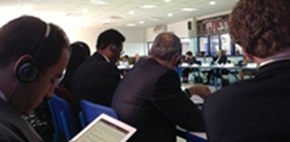The Action of the Lebanese Government is Far Beyond its Capacity/* Khaldoun el Charif, head of the Lebanese-Palestinian Dialogue Committee (LPDC) called the donor countries “to assume their responsibilities in shoring up Lebanon and the international agencies and organization in charge of supporting the displaced to help them undertake their tasks, he stressed the positive role of UNRWA, despite the scarcity of its resources and considered that the action of the Lebanese government was far beyond its capacity.

El Charif’s statement was issued in the frame of the UNRWA Advisory Sub-committee meeting held in Amman, Jordan, including representatives of Palestinian refugees host countries, donors and international community representatives.

During the meeting, El Charif presented an overview of both the Lebanese and Palestinian and Syrian displaced hardship, calling upon all parties to share this burden. LPDC’s head paid attention to the statements of the donor countries representatives who expressed goodwill and sincere readiness to assume a more efficient role that will gradually materialize in the coming phase. Agreement was reached on resuming contacts and follow up to secure a good coordination on all levels.

* **UN Special Coordinator , Derek Plumbly, Discusses Refugees issue**

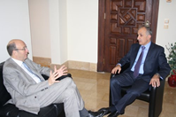UN Special Coordinator, Derek Plumbly, met several times with Khaldoun el Charif, to discuss the situation of the displaced Syrians and Palestinians on Lebanese territory and means to bolster the international support to cater for their urgent needs.

The discussions tackled the issue of the Undocumented Palestinians (Non-IDs), the fruitful collaboration with the Lebanese Security General apparatus in this regard, and matters related to the displaced. Plumbly updated el Charif on many steps undertaken by the international community and the positive implications for Lebanon.

* 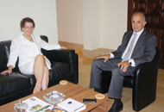**Canada Supports a Proposal to Cater for Palestinians**

The Canadian Ambassador to Lebanon, Mrs. Hilary Childs-Adams discussed at many occasions with Dr. Khaldoun el Sharif the latest local and regional developments, especially the refugees’ issue, touching upon means to support the Lebanese Government in drafting a proposal to cater for Palestinian Refugees affairs in Lebanon. Childs-Adams updated el Charif on the international efforts to contain any negative repercussions of the Syrian crisis on the Lebanese situation, reiterating the need to support Lebanon at this juncture.

* **Norway at the Forefront of the Relief and Development Efforts**

LPDC held a series of meetings with the Norwegian Ambassador to Lebanon, Svein Aass, who said that “Norway has a tradition of doing what it can in response to major 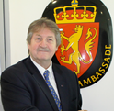international refugee crises and of providing a safe haven for refugees.” He praised Lebanon for the shelter provided to Palestinian and Syrian refugees, “Lebanon has displayed an enormous sense of responsibility within its limited capacities, it is therefore crucial that Norway and other like-minded countries show solidarity.” Supporting LPDC is included in the Norwegian embassy’s agenda, especially in projects related to development and youngster empowerment.

Since the start of the conflict in Syria in 2011, Norway has provided a total of NOK 850 million (145 million USD) in humanitarian aid to Syria and neighboring countries. Also, the Government decided recently to accept 1 000 Syrian refugees for resettlement to Norway. The Norway remains as well one of the LPDC project main donors in 2013 and 2014.

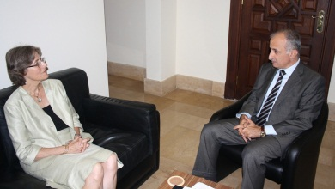

* **Swiss Ambassador Swiss Ambassador, Ruth Flint**, being the LPDC largest donor, through SDC, discusses Switzerland support to Development Projects and the major challenges facing LPDC and the efforts exerted by LPDC to achieve progress on various fronts.
* **Japan Supports the Rehabilitation of an Infrastructure Project in Ain el Helwe and discusses the situation of the Displaced**

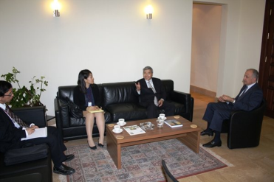LPDC president, Dr. Khaldoun el Charif, discussed with the Japanese Ambassador to Lebanon, Tokumitsu Murakami, the implementation of the Japanese assistance previously granted through JICA (Japanese International Cooperation Agency) and allocated to rehabilitate the first phase of the sewage network upgrading in Ain el Helwe camp. LPDC assumed the follow up action on the Japanese grant to remove any hurdle hindering its implementation. The Japanese ambassador updated El Charif on the implementation stages of the Ain el Helweh Sewage network rehabilitation.

The Japanese Ambassador and LPDC’s president examined the situation of the displaced on Lebanese territory, namely the Palestinian displaced coming from Syria.

* **Austria Seeks to Support the Displaced**

The Austrian Ambassador to Lebanon, Ursula Fahringer conveyed Austria’s readiness to support Palestinian and Syrian displaced residing on Lebanese territory.

* 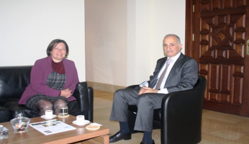**Belgian Ambassador and el Charif Discuss the Situation in Ain el Helwe camp/**

The Ambassador of Belgium, Colette Taquet, visited the LPDC’s headquarters to set up cooperation mechanisms aiming at alleviating tensions and soothing off the climate in the southern camps in general, namely in Ain el Helwe, placing it as a top priority for LPDC in the upcoming stage.

* **Danish Ambassador, Jan Top Christensen, leading the drive to mobilize** funds to support Palestinian Refugees projects: Ambassador Christensen pledged support to LPDC in implementing its mandate.
* **Romanian Ambassador, Daniel Tanase, met with LPDC’s head to** discuss matters related to the situation of Palestinian refugees and means of cooperation in light of the previous contribution of Romania within the frame of the donor countries.

* **US Ambassador and LPDC’s president to Improve Living conditions of Palestinian Refugees.**

**LPDC president and US Ambassador, Maura Connelly, agreed on enhancing** cooperation aiming at improving the living conditions of Palestinian refugees on Lebanese territory. The discussion tackled the situation in and around the camps and the stages already completed in the NBC reconstruction, stressing the need to resume the funding drive by urging the donor parties that took part to the Vienna conference, to honour their pledges and find new funding sources.

* **Australian Ambassador, Lex Bartlem,** Announced that Australia allocated 90 m USD to assist Palestinian refugees for the next 5 years.
* 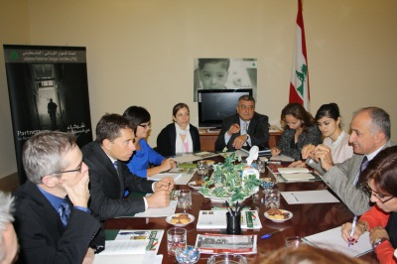**UK Ambassador, Tom Fletcher,** discussed means to alleviate tension. Heading a British delegation, the UK Ambassador conveyed his country’s readiness to provide assistance to several programs aimed at empowering Palestinian youth and setting up mechanisms of cooperation to alleviate tension in the camps.
* **Ambassador of Finland meeting el Charif:** Finnish ambassador Kari Kahiluoto met LPDC president to discuss means of supporting the actions and programs targeting Palestinian refugees.

1. ***Nahr el-Bared reconstruction:***

LPDC support team; since the dismantle of the RRC (Reconstruction and Relief Cell) at the Prime Minister Office; has been leading the coordination and facilitation role on behalf of the GoL and worked closely with the concerned public institutions and UNRWA to overcome the bureaucratic delays regarding reconstruction programing.

In camp Adjacent Areas, with support from CDR and Palestinian Embassy, LPDC reactivated and mobilized the reconstruction/rehabilitation works in Al-muhajareen Project, the Italian Grant (Phase two) and the Greek Grant for infrastructure.

* **Italian Grant for rehabilitation Phase 1-2**

Towards the end 0f 2012, the completion of works of the first phase Italian grant was still pending due to disputes and claims between the contractors and the Central Funds for Displaced CFD and Council of Development and Reconstruction CDR.

The LPDC with support of the Italian Embassy facilitated the resolution of all claims of the first phase and launching the second phase incorporating lessons learned.

* **Greek Grant for infrastructure**

This grant was pending at the CDR for more than 3 years in result of lack of coordination among stakeholders. LPDC with the support of the Palestine Embassy and technical support from UNRWA initiated a project to divert the initial proposal into a local community project. CDR has adopted the project and receives the approval of Greece Embassy and currently under tender.

* **Fundraising mobilization**

The LPDC and PMO continue to support UNRWA’s effort to fundraise the NBC reconstruction project. Knowing the current fundraising challenges, the PM has drafted support letters that were disseminated across the Gulf region to highlight the commitment of the GOL to the reconstruction of the NBC and the return of its refuges.

1. ***Extending Partnerships:***

* **Sealed Partnership LPDC/Common Space Initiative via a Memorandum of Understanding**

The Lebanese Palestinian Dialogue Committee (LPDC) and Common Space Initiative (CSI) held a launching event at the Grand Serail to seal a Memorandum of Understanding initiating an inclusive dialogue forum where a group of experts will discuss, exchange, and develop a common understanding on the Lebanese-Palestinian relations and provide advice and support to all formal and non-formal entities working on the Lebanese-Palestinian dialogue and Palestinian refugees’ issues.

The Lebanese-Palestinian Dialogue Forum Review: CSI and LPDC have been working on evaluating and reviewing CSI support services to the Lebanese-Palestinian Dialogue Forum. Several additional resources and tools to respond to the forums’ needs and issues were developed. Meetings and Forums: CSI and LPDC held meetings with heads of Palestinian syndicates, facilitation meetings and The Lebanese-Palestinian Dialogue Forums.

1. ***Meetings to deal with the influx of Palestinian refugees coming from Syria***

Several emergency meetings were held at the Grand Serail between the head of LPDC and Representatives of All Palestinian Factions, some were headed by the minister of Social affairs, Wael Abou Faour, to stress the Government of Lebanon resolve to exert all efforts locally and internationally to face the problematic issues stemming from the influx of Palestinian refugees coming from Syria, especially after the recent developments in Yarmouk camp.

The representatives of the Palestinian factions underlined the need to deal with the Palestinian refugees “on a par and according to the same standards applied to Syrian refugees”, while taking into consideration that UNRWA should assume the responsibility of the basic services aimed at accommodating them temporarily until they return to Syria.

Discussions focused on the main outcome of the UNRWA study related to the expected number of Palestinian refugees who are liable to enter all neighboring countries, including Lebanon during the next six months. The study was submitted to the concerned international parties in Geneva in the frame of a work meeting aimed at discussing means of supporting the relief efforts. LPDC will lead on the plans to secure funding and relief programs until they safely regain their homes

## Output 3: Policy and substantive advice provided to the inter-ministerial committee and the Government of Lebanon on Palestinian Refugees civil rights

As part of the work that the LPDC carried out for the purpose of providing the GoL with substantive advice, the technical support team attended several workshops, meetings and conferences with aiming at enhancing and sharing its knowledge base on the human rights of Palestinian refugees in Lebanon. Moreover, the LPDC led on a number initiative pertaining to Palestinian refugees human rights, namely:

1. ***Right of Palestinian Refugees to Form Associations***

In Lebanon, associations are regulated by the law dated 1909, later completed by the law dated 1962. According to these two laws, associations may be created freely, in addition to the condition that “any association under construction must send a notification announcement to the Ministry of Interior and Municipalities”. Despite the fact that this law did not distinguish between citizens and foreigners, the Law no. 369 LR dated 1939 stipulates that foreigner associations should have a prior permission that must be issued by a special governmental decree. By including the principle of reciprocity as a condition precedent, the Palestinians are deprived from the right to establish associations. Moreover, this regulation was complemented by the law No. 629 dated 2004, which concerns the “Organization of the Ministry of Youth and Sports”. This law requires that founders of associations should be Lebanese over eighteen years old.



In this regard, within the scope of the LPDCs’ work, LPDC has conducted a legal consultancy with the anticipated following results:

* + Policy paper highlighting key issues regarding the provision of the right to form associations to Palestinian refugees.
  + Mapping national constitutional, legal and policy frameworks and ratified international conventions concerning the right of Palestinian refugees to form associations in Lebanon.
  + Analytical report identifying the gaps between the local legal framework and provisions of the ratified international conventions regarding the issue;
  + Analytical report identifying the projects/activities/programs carried out in Lebanon related to the “right of Palestinian refugees to form association” sector, possible progress and areas of synergies;
  + 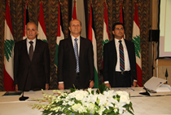National assessment of the current situation of the Palestinian or Lebanese-Palestinian organizations existing in the Lebanese territories.
  + A proposal of an amendment of the Lebanese implementation procedure pertaining to Association law;
  + Synthesis executive report identifying the major issues, gaps and challenges, priorities and policy suggestions’ directions in relation to the legal policy to be taken by the LPDC with regard to this issue.

The study has been finalized and delivered to LPDC. A conference was organized with the DPRA to present the outcome in August 2013 to present the outcome.

1. ***LPDC participation in Events, Seminars and Conferences hosted by Partners and Stakeholders***

* *The Right to Work Coalition conference*: LPDC participated to “the right to work for Palestinian Refugees in Lebanon” conference prepared by the right to work Coalition and IFI under the supervision of Dr. Sawsan Abdel Rahim and Dr. Aziza El Khalidi.
* *The ILO "Connectivity with Employers*" workshop was held on February 2013: prepared by the ILO in collaboration with the Chamber of Commerce, Industry and Agriculture of Beirut and Mount Lebanon.
* *Seminar on the implications of the Syrian crisis* on the Palestinian refugee community in Syria: held by Aidoun discussed the implications of the Syrian crisis on the Palestinian refugee community in Syria.
* *Seminar on “the Situation facing Palestinian Refugees in regard to the Ban on Real* Estate Ownership in Lebanon” by NRC.
* *ICLA Seminar on the Norwegian Refugee Council’s project* on the situation facing Palestinian Refugees regarding the ban on real estate ownership in Lebanon with a discussion moderated by Dr. Khalil Al Dahdah.
* NRC training on “*Housing, Land and Property*”: a two-day training conducted by advisors from Oslo related to Housing, Land and Property rights for Palestinian Refugees.
* The *CEP Plenary/Strategic Retreat*: an informal open discussion that will pave the way for Concrete Decisions that will be ironed out and consensually adopted at follow-up meeting: Vision, Mission and Goals.

1. ***LPDC –CSI Labor guide: Labor rights of Palestinian refugees in Lebanon***

The Lebanese Palestinian Dialogue Committee (LPDC) and Common Space Initiative (CSI) initiated an inclusive dialogue forum and expert group to discuss, exchange, and develop common understanding on the Lebanese-Palestinian relations and provide advice and support to all formal and non-formal entities working on the Lebanese-Palestinian dialogue and Palestinian refugees’ issues.

LPDC participated in drafting a guide describing the profile of employment conditions of Palestinians refugees in Lebanon. This guide provides a selective bibliography and knowledge resources on Palestinian Refugees Labor Rights in Lebanon. It constitutes a platform for ongoing knowledge sharing and accumulation around the stated issue.

1. ***study on the Palestine State***

The LPDC is conducting a study to identify the implications of the ‎recognition by the United Nations General ‎Assembly of ‘Palestine’ as a non-member ‎observer state on the current status of ‎Palestinians in Lebanon. The purpose of the study is to improve the Lebanese legal system by adapting it to the recent changes produced by the impact ‎of the recognition of Palestine as non-‎member observer state at the UN on the ‎Lebanese legal regulatory framework ‎pertaining to the General Clause of ‎Reciprocity applied on Palestinian ‎Refugees.

The Terms of Reference has been prepared (Annex 1) and published and the expert has been chosen. It is expected to finalize the study by the first mid of 2014.

# MAJOR ACHIEVEMENTS 2013

## Towards a Unified National Policy for the Palestinian Refugees in Lebanon and a future vision for LPDC

1. ***The Rationale***

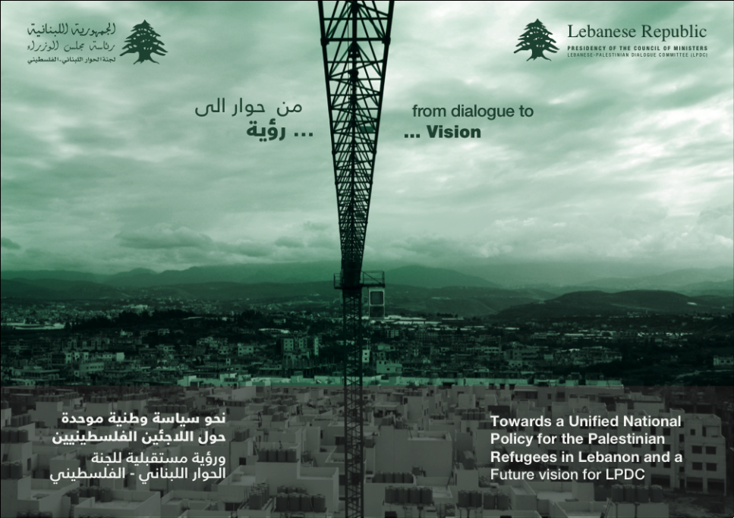The LPDC, based on the direction of the Prime Minister, has conducted in the beginning of the 3rd quarter an internal evaluation testing its performance against the initial mandate and role. Under the title” *Towards a Unified National Policy to Govern the Palestinian Refugees file in Lebanon & Future Vision for LPDC*” and with activities support from IDRC; the LPDC president initiated and managed a process of consultation and discussion with key stakeholders on the Palestinian refugee issue in Lebanon with the objective of developing a policy options document to the GoL including options for the management of the Palestinian refugees file in Lebanon, while developing a future vision for the LPDC.

This process of consultation was based on the experience of the work of the LPDC since 2005 and its technical staff. It involved past LPDC Presidents, representatives from key political parties in Lebanon, representatives and ministers from the different ministries that are part of the LPDC technical committee, UN officials, Palestinian factions officials in Lebanon and key Palestinian and Lebanese academics and experts on the refugee issue as well as representatives from civil society organizations.

In result, a law proposal was drafted including a complete restructuring of the LPDC into a High Commission for Palestine Refugee Affairs, with an expanded mandate to lead on formulating a unified national policy on Palestinian affairs. The Commission would have a Planning Department and an Executive Department; the former comprised of a Strategic Planning Division whose role would be to develop medium and long term action plans to improve camp conditions in coordination with UNRWA, and a National Observatory Unit tasked with conducting a comprehensive survey and collecting and consolidating all data on Palestinian refugees to inform policy-making, as well as monitoring and documenting all developments pertaining to Palestinian refugees nationally, regionally, and internationally. The latter department would include a Coordination Division and a Communication and Media Division.

Though this draft law is pending a Cabinet decree and parliamentary approval, the announcement of this re-structuring proposal from the Serail, under the patronage and support of Prime Minister Mikati, strongly indicate that all parties have agreed to it. The LPDC is moving forward in discussions with donors to fund the implementation of several of these activities as a precursor to the formal establishment of these units. President Khaldoun welcomed and strongly supported the development of an in-house monitoring capability, viewing this as a key step in developing the Observatory Unit, as well as enhancing the Lebanese state’s ability to play a greater role in coordinating aid and development in the camps with UNRWA and the international community, as well as have increased oversight and influence on service delivery. Given the expected rise in the number of PRS arriving with worsening security conditions in Syria, it is becoming more critical that the Lebanese state is better equipped to manage and coordinate aid and relief efforts.

1. ***Consultation Meetings***

Consultative Meetings sought to engage both Palestinians and Lebanese parties within the frame of open and transparent debates including representatives from key political parties in Lebanon, representatives from the different ministries that are part of the LPDC technical committee, UNRWA officials, Palestinian officials in Lebanon and key Palestinian and Lebanese academics and experts on the refugee issue as well as representatives from civil society organizations.

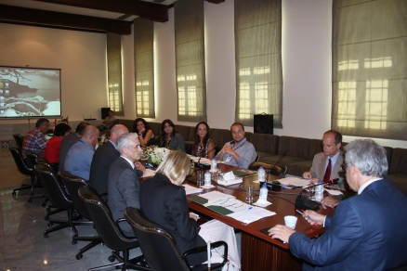Additional meetings and consultations were undertaken with past LPDC Presidents (H.E. Khalil Mekkawi, H.E. Abdel Majid Kassir and Me Maya Majzoub). Other meetings and working lunches included partner-NGOs (Common Space Initiative (CSI)…) to define the needs and listen to suggestions and rational opinions about the re-structuring process and the amendment of the LPDC mandate.

Based on the past experience of LPDC since 2005 and the work of its technical staff, key issues and questions were addressed about the LPDC’s mandate and its evolution since 2005 with the simultaneous presidency, the lessons learnt from the experience on the ground, the external and internal challenges stemming from the nature and prerogatives, Lebanon’s representation and perception among Palestinian community, regionally among Arab countries and UNRWA; the relation with UNRWA, with Palestinian officials and with Lebanese officials and politicians and finally the relation with donor communities as well as other international organizations.

The most important element that was discussed was related to the needed institutional re-structuring that LPDC should undergo in order to manage the refugee’s file in Lebanon in the short, medium and long terms. The major outcome was to submit a proposal to the Government of Lebanon to place this re-structuring process in a legal framework and outline a clear policy towards the Palestinian refugees residing on Lebanese territory.

1. ***Drafting* *the Policy Document***

A retreat to the LPDC team with the help of appointed consultants was conducted to filter and segregate the information and proposals generated from the consultative meetings. A skeleton including different chapters was outlined seeking the best way to improve, amend and add to finalize the draft before sending it to printing production. Brainstorming sessions and a comprehensive review of all the parts was performed to produce the final document.

1. ***Launching Event***

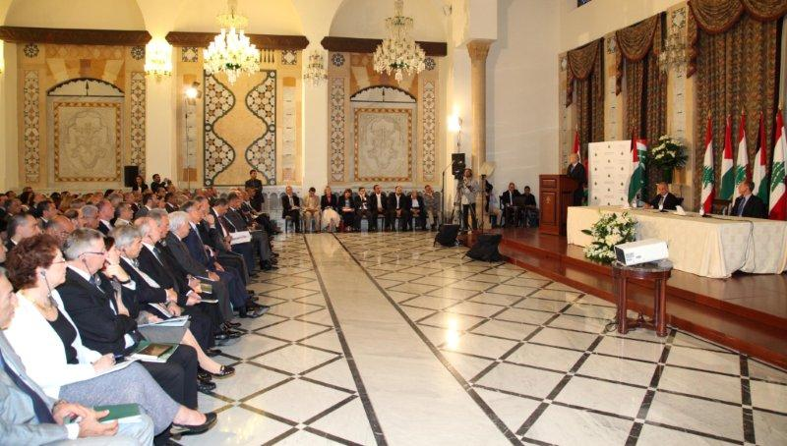Under the patronage of PM Najib Mikati and based on the recommendations stemming from the series of consultative meetings organized by LPDC with all stakeholders and parties concerned with the Palestinian refugees issue, LPDC held a launching event to present its vision titled: “Toward a Unified National Policy for Palestinian refugees in Lebanon and a Future Vision for LPDC”. The event was attended by a crowd of officials, diplomats, experts and concerned parties; it features a presentation of the most important recommendations and an outline of the suggested re-structuring process.

Dr. Khaldoun el Charif addressed the audience noting the compelling reasons that led to drafting this proposal, urging the parliamentarians to thoroughly examine the proposal before transferring it to the Council of Ministers for approval.

UNDP Resident Representative, Robert Watkins, underlined the support offered by UNDP in various fields and PM Mikati concluded the meeting by stressing the important role of LPDC at this delicate juncture.

1. ***Presentation trip to the US and Canada to introduce the document***

Following the completion of the activities, a trip was organized for the LPDC President to visit USA and Canada to present the outcome of the exercise that was implemented throughout three months. The objectives were:

* To promote the LPDC new vision: “Towards a Unified National Policy towards the Palestinian Refugees in Lebanon and Future Vision for LPDC”;
* To raise funds for the LPDC project for the upcoming 2014-2015;
* To discuss UNRWA’s ADCOM and Lebanon chairmanship.
* This trip had many positive repercussions:
* Raising awareness about the exclusive role of LPDC as the sole caterer for Palestinian Affairs in the Lebanese administration (the DPRA being only entrusted with the administrative aspects);
* Exploring support opportunities to the LPDC action plan in terms of funding and logistics;
* Consolidating the network of partners;
* Keeping the Palestinian Refugees’ issue on the international agenda as an element of stabilization;
* Discussing Lebanon’s role as a host country in the upcoming Peace Negotiations.

The road show paved the way to further interact with the international community. Especially in light of the continued peace process direct talk, in which Lebanon might play a vital role as a host country. In fact, within the frame of the new proposal to re-structure LPDC, monitoring and supporting the peace process is considered a main pillar in moving the LPDC action towards a new level of involvement in the political sphere as an executive tool to the decision-making process.

Another main objective was reached at the level of internal and external communication for greater visibility and outreach to promote LPDC‘s mission.

## UNRWA Advisory Commission (AdCom) meeting/ June 17, 2013 (Dead Sea, Jordan)

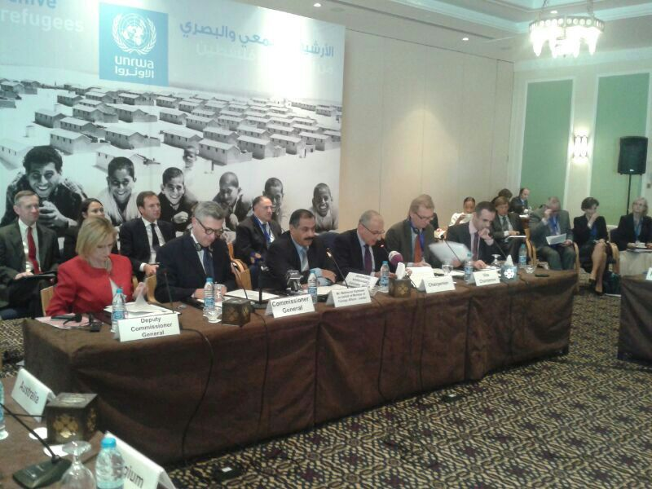 “The capacity of the host countries to cater for the new comers of refugees is becoming genuinely alarming”, stressed Dr. Khaldoun el Sharif, ADCOM Vice-chair and LPDC president, during the UNRWA Advisory Commission’s meeting held in Amman-Jordan, to examine and discuss the recent reforms the Agency is undertaking in light of anticipated difficulties in securing funding. UNRWA is facing daunting challenges at the level of the quality of programmes, budget planning and reform strategies and services delivered to Palestine refugees in its fields of operations as well as in its budget deficit and long-term sustainability.

As Vice-Chair, el Charif stressed the need to support UNRWA’s reform drive and future plan. He urges the donor countries to provide the needed funding especially at a time when “the number of Palestinian Refugees from Syria is constantly increasing hence weighting on the host countries and affecting the political, social and security situations.

In parallel, the services and resources of UNRWA are waning, which forestalls a difficult way ahead. The situation requires mobilizing both efforts and funds. It becomes compelling to adopt an innovative approach that should be implemented by all three partners (host countries, international community, UNRWA) on the levels of cooperation and coordination, based on mutual trust.” El Charif called upon all Palestinian factions to dissociate the camps from the Syrian conflict while expressing the readiness of the host countries to cooperate with the international community to deal with the problematic issue. He warned, “The capacity of the host countries to cater for the new comers of refugees is becoming genuinely alarming.”

# ****COMMUNICATION AND OUTREACH****

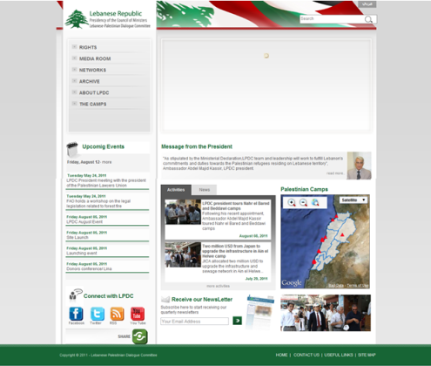Upholding the current management structure, improving the capacity of the LPDC, strengthening the role of the inter-ministerial committee and alleviating administrative procedures will help in bolstering the public’s confidence and present LPDC’s work as credible, transparent and inclusive. An active communication and exchange channels are needed to present all positive outcomes and ensure transparency by relying on various channels and tools:

## Tools: Website, Social media and Newsletters

The current Hosting environment is cater for an average of 2000 unique visitors per month, unlimited disk space as well as a bandwidth of 1GB of monthly traffic

This major shift to a modern and advanced portal replaced a primitive HTML coded and old website Hosted and managed by a limited featured back office which wasn’t able to be developed. Furthermore, it provided smooth and easy operation to manage and update and even create new sections or submenus inside the current website when needed

1. ***Website***: During the past year we focused on upgrading LPDC’s digital image: the LPDC website [www.lpdc.gov.lb](http://www.lpdc.gov.lb) has been developed to reflect the new vision and action.
2. 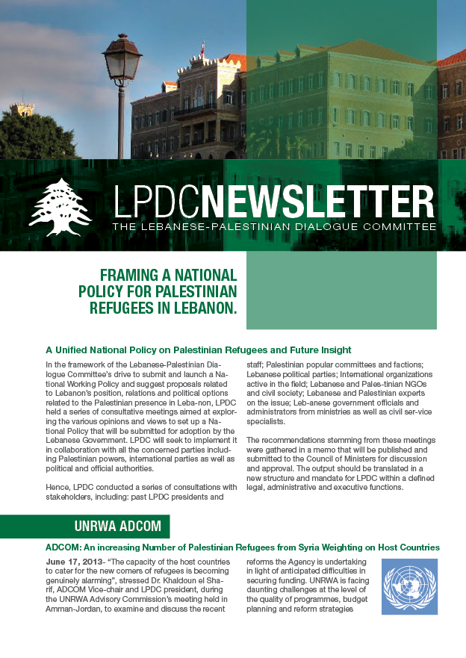***Social media****:* *Facebook* and *Twitter:*:

* A Facebook is updated in parallel with LPDC’s website.
* A Twitter subscription provides timely tweets about LPDC’s major actions and allows following different stakeholders and related partners.

1. ***Newsletters 9***

The issuance of Newsletter 9 seeks to present LPDC’s work and strategy: summaries of activities are released in both English and Arabic to reflect the technical team, and president’s activity to the various audiences: Lebanese public, Palestinian refugees and international community.

# IMPACT

Based on the work carried out during the past year and the achievements highlighted in this report, the following levels of impact should be put forward:

1. The LPDC was able to get back on track after a prolonged transitional period. It continued to play a central operational role in the reconstruction of NBC, supporting key coordination mechanisms, and working closely with UNRWA on resolving problems with Lebanese ministries;
2. The LPDC succeeded in reaching out to all 12 Palestinian refugee camps in Lebanon, acting as the Government’s civilian face among the Palestinian community representing the Lebanese Government’s policies. The LPDC has managed to establish a regular communication and coordination process with all camps through their community key representatives (i.e. popular committees) representing all parties and factions. The emphasis has been the inclusion of all parties in the LPDC coordination efforts with no exception of any faction or group. This strategy allows the Lebanese government through the LPDC to grasp a broader view of the Palestinian socioeconomic and political landscape .
3. Despite a complicated political environment in Lebanon, the LPDC took the first steps towards enhancing the relationship between a number of Ministries (e.g. the Directorate of Political and Refugee Affairs at the Ministry of Interior and Municipalities and the Directorate General of Security General and the Palestinian refugee community. It aims to support these Ministries in strengthening their capacity to respond to the specific needs of Palestinian refugees in Lebanon mainly, the Directorate of Political and Refugee Affairs at the Ministry of Interior. In continuation of an initiative started in 2012, the LPDC support continued to DPRA in 2013.
4. For the first time and in most camps, Palestinian community feel that the Lebanese government is considering the Palestinian community in general and the camps in particular from a non-security perspective rather from a civilian angle which will, according to members of popular committees, positively impact the Lebanese Palestinian relationships.

# KEY CHALLENGES

## **1) Inter– governmental level**:

- Lack of awareness among governmental institutions towards Palestinian community and the situation on the ground inside the Palestinian camps and gatherings.

- Lack of understanding of the LPDC role: some if not most departments within governmental institutions still lack information and awareness regarding the LPDC’s role and responsibility.

- Lack of resources within public institutions.

## External – field: camps and gatherings level:

- Limited understanding of the LPDC’s mandate.

- Lack of understanding of the LPDC role as a consultative body providing recommendations to the PM office.

- Lack of resources at the local level to address the needs of Palestinian camps and gatherings.

- Lack of coordination between all relevant stakeholders.

## Project implementation Level:

* Limited financial resources for the project, fundraising is taking place on yearly basis. In 2013, the project lacked funding during the 1st half of the year.
* With the resignation of PM Mikati cabinet back in April, the LPDC president has also resigned from his position and currently care-taking the post. A new president is expected to be assigned with the formation of a new cabinet and this shift in expected to affect the pace of work at the LPDC.

# PROPOSED ACTION PLAN

## Establishment of the National Observatory for Palestinian Affairs

Although the Palestinian refugees in Lebanon are highly surveyed and studied by different stakeholders, however it’s never been recorded that any official body had ever conducted surveys in camps. For example, the population of Palestinian refugees remained an estimation includes a gap between UNRWA figure of 450.000 and the latest AUB study which estimated 210.000 refugees currently residing Lebanon. The absence of official comprehensive and accurate data mainly affected the ability of the GoL to base sound policies towards Palestinian refugees on solid grounds.

In order to facilitate this goal however, there is a massive need for clear and accurate information and statistical data on living conditions and urban profile in the Palestinian camps, adjacent areas and gatherings, the three geographical distinctions which constitutes a gap today. The GoL will require a policymaking tool that shall enable generating knowledge, developing indicators and monitoring living conditions to guide systematic public policy discussions by Government bodies and officials.

Therefore, the LPDC new vision “*Towards a Unified National Policy for the Palestinian Refugees & Future Vision for LPDC*” concluded with the importance of laying the GOL policies towards Palestinian refugees on indicators based on accurate information and statistical Data and therefore suggested the formation of a **National Observatory Division** mandated with:

* *Prepare a comprehensive survey and collect information and data related to the Palestinian presence in Lebanon as a tool for decision-making and policy-making;*
* *Monitor and document the developments and decisions pertaining to the Palestinian issue at the Arab, regional and international levels.*

As such, LPDC along with the support of the PMO and Lebanese public administrations will be working towards establishing a “National observatory for Palestinian Affairs in Lebanon” (Annex 2) in 2014-2015 which will be a platform to integrate all sorts of databases and existing studies into a unified structure. This “new” form of knowledge will support the LPDC’s effort to recognize and enhance its interlocutor role among the governmental/ international and local bodies. In addition, it will help to formalize clear criteria for prioritizing projects and programs.

In particular, this project will seek to respond to the priorities of the LPDC, as outlined by the President of the Committee, Dr Khaldoun el Charif on October 2013:

1. Activating the LPDC and its partner public institutions;
2. Strengthening and building the capacities of ministries and institutions directly engaged with Palestinian issues;
3. Carrying out official statistics with regard to the Palestinian presence in Lebanon;
4. Setting up an Observatory to gather all data and efforts related to the Palestinian refugees issues;
5. Supporting the decision-making procedures of the GoL by providing technical advice;
6. Setting coordination mechanisms with the Palestinian counterparts in anticipation of the peace negotiations and potential peace agreement (implementation of the Right of Return”)
7. Strengthening the partnership with UNRWA, ESCWA, the State of Palestine and all active actors;
8. Participating in national and international forums with other host countries to support the coordination among them.

The objective of this 2014 Action Plan therefore remains to strengthen the capacity of the LPDC to establish the National Observatory for Palestinian Affairs that enables the GoL to generate a comprehensive policy on the Palestinian refugee issues, with a view to improving their living conditions. The consolidation of data serves to monitor (baseline reference) the improvement in the living conditions of Palestinian refugees while setting the stage for the implementation of any upcoming peace agreement on various levels: administrative procedures, indemnities and Right of Return, in accordance with other host countries. To realize this objective, the Action plan will consist of the following components:

**Component 1:** Administrative and technical support provided to the establishment of the National Observatory through the inter-ministerial committee and the technical committee;

**Component 2:** Population and Housing Census in the Palestinian Camps and Gatherings carried out in partnership with the Central Administration of Statistics (CAS) and Palestinian Central Bureau of Statistics (PCBS);

**Component 3:** Capacity Building for Lebanese Public administrations mandated with the registration of Palestinian Refugees.

## Enhancing Lebanon’s Response to the influx of Palestinian refugees from Syria: Monitoring Service Delivery in the Palestinian Camps of Lebanon

The influx of an estimated 49,500 Palestinian refugees from Syria (PRS) to Lebanon’s Palestinian camps and gatherings has added substantial pressure on an extant fragile situation. Crowded living conditions, inadequate service provision, weak or non-existent governance structures and mechanisms, and a precarious security situation have all been exacerbated by the arrival of PRS and the spill-over of the Syrian conflict.

Despite a surge in efforts by both UNRWA and local Palestinian NGOs, PRS still report the insufficient aid is reaching them, while Palestinian refugees in Lebanon (PRL) are increasingly reporting deterioration in the services and aid they already receive. Over July and August 2013, Pursue conducted a large-scale household survey in the four camps hosting the largest number of PRS families; ‘Ayn al-Hilweh in southern Lebanon, Baddawi in the north, Bourj al-Barajneh in the southern suburbs of Beirut, and Jalil in the Beqaa. It concluded to: *While most PRS households had received some form of aid in 2013, the majority of PRS households lived in abject poverty – the highest rates of abject poverty were reported in Jalil at (95%) and the lowest percentage in Bourj al-Barajneh (55%).*

As such, the LPDC will be working to establish a monitoring unit continuously monitors and assesses UNRWA and non-UNRWA service delivery to all Palestinian refugees in Lebanon, in collaboration with local and Palestinian stakeholders, in order to enhance service and relief response to refugees. This unit will contribute to the establishment of the National Observatory Division planned as part of the LPDC’s reformed structure. The expected outputs shall be:

* 1. An assessment of the effectiveness and impact of current service and aid delivery in all 12 Palestinian refugee camps through a comprehensive survey, the data of which will form a component of the database to be established by the LPDC’s monitoring unit.
  2. A databank of all PRS aid and relief efforts to inform coordination. With a Lebanese state mandate, NGOs are more likely to respond positively to data sharing requests.
  3. Monitoring unit staff are capacitated in service delivery monitoring and evaluation, and develop short and medium-term plans and mechanisms for continuous assessment.
  4. A pool of assessment partners and consultants from local stakeholders is formed to assist in assessments and participate in analysing and disseminating lessons learned.

# ANNEX 1

***Terms of Reference***

***Impact of the Recognition of Palestine as non-member state observer at the UN on the Palestinian refugees’ legal status in Lebanon and the Clause of Reciprocity.***

1. **Project Description**

|  |
| --- |
| The LPDC is an inter-ministerial government body established by the Council of Ministers’ decision number 89/2005 in October 2005; it is based at the Presidency of the Council of Ministers. The LPDC is mandated to support the Lebanese Government by looking into the following four issues:   * Deal with matters related to the living, social, economic, legal and security aspects inside the camps of Palestinians living on Lebanese territory, in collaboration with UNRWA; * Develop a mechanism to put an end to the Palestinian armed presence outside the camps; * Initiate dialogue regarding the regulation and control of Palestinian weapons inside the camps; * Study the possibility of establishing representative relations between Lebanon and Palestine.   With funding from the international community and management support from the United Nations Development Programme (UNDP), LPDC grew in capacity and expanded its scope of activities. As such, the President of LPDC, with the assistance of UNDP, recruited a team to serve as a technical support unit to assist and expand LPDC’s work. Alongside the committee, the LPDC team pursues a distinct mandate. This includes, but is not limited to, the following activities:   1. Provide technical support and assistance in the application of government policy in all efforts and events relating to Palestinian refugees in Lebanon 2. Coordinate between the various ministries regarding the application of government policy 3. Collaborate with UNRWA on a range of issues including the improvement of refugee camps infrastructure 4. Initiate and sustain dialogue with the various Palestinian groups and civil society organizations 5. Coordinate with international and Arab donor countries to raise funds for the implementation of new policies 6. Promote dialogue and understanding between Lebanese and Palestinians 7. Maintain contacts with Lebanese political parties, religious leaders and civil society to promote government policy 8. Participate in relief operations and coordinate with relief recovery and reconstruction efforts during and after crises 9. Liaise with local and international non-governmental organizations (NGOs) and civil society groups |

1. **Scope of Work**

|  |
| --- |
| Under the supervision of the LPDC President and in coordination with the Project Manager and the Legal Officer, the Legal consultant will provide the following services:   1. Draft a concept paper outlining the legal characteristics of an Observer State and the impact of this status within the frame of the Lebanese law; 2. Identify the role of Lebanon in supporting the Palestinian statehood; 3. Collect the available data and information on the existing Lebanese legal regulatory framework of the application of Reciprocity clause ( Right to work, Right to access to Social security services, Right to own property, Right to form associations, and other human rights); 4. Assess the impact of the recognition of Palestine as a non-member observer state at the UN on the clause of reciprocity in general, namely the right to own property; 5. Classify the implications of the recognition of Palestine as a non-member observer state at the UN on the Palestinian representation in Lebanon and on the right of Return; 6. Identify the implications of the recognition of Palestine as a non-member observer state at the UN on the current status of the Palestinian official representation in Lebanon; 7. Define the roles of each of the PLO, the Palestinian authority, the Palestinian embassy in the Lebanese territories and the diplomatic representation of Lebanon in the Palestinian territories after the recognition of Palestine as an observer state; 8. Draft a proposal of a possible general revision of the Lebanese legal texts related to Palestinians rights in Lebanon, based on the recognition of Palestine State; 9. Actively involve stakeholders in drafting this general revision. |

1. **Expected Outputs and Deliverables**

|  |  |  |
| --- | --- | --- |
| Deliverables/ Outputs | Estimated Duration to Complete | Review and Approvals Required (Indicate designation of person who will review output and confirm acceptance) |
| **Submission of the first report including the identification of the implications of the recognition by the United Nations General Assembly of ‘Palestine’ as a non-member observer state on the current status of Palestinians in Lebanon.** | 2 months after the signature of the contract | Project Manager/Legal Officer  LPDC president |
| **Submission of the second and final report including the identification of the impact of** the recognition of Palestine as non-member observer state at the UN **on the Lebanese legal regulatory framework pertaining to the General *Clause of Reciprocity* applied on Palestinian Refugees.** | 4 months after the signature of the contract | Project Manager/Legal Officer  LPDC President |

1. **Institutional Arrangement**

|  |
| --- |
| The contractor will liaise with the Project Manager and the Legal Officer during the course of performing his work.  UNDP and LPDC will be responsible for providing the expert with information related to the UN recognition of states and to the rights of Palestinians in Lebanon, in a timely thorough and transparent manner. |

1. **Duration of Contract**

Four months

1. *“Socio-Economic Survey of Palestine Refugees in Lebanon”, 2010/ UNRWA/ American University of Beirut, funded by the European Union*.